Quickly solve PC problems with TechRepublic's Quick Reference: PC Troubleshooting Pak. The set of four durable laminated charts keeps proven solutions for troubleshooting PC hardware, networking, Windows desktop and security issues at your fingertips.
The old cliché says that nothing is constant except for change. That's often very true when it comes to configurations on your workstations. You add devices, remove devices, and shuffle things around inside of the case. Every time you do, Windows XP happily changes its configuration, adding device drivers and changing settings. Most of the time, it will remove drivers too.
XP's Device Manager allows you to view installed devices, but with a little bit of tweaking, you can also make it display devices that are no longer installed in your workstation. Here's how it works.
Why you want to see missing drivers
Windows XP usually does a good job of managing system resources. Because most new devices are Plug And Play, along with the fact that Plug And Play is much better now than it was when it first debuted, XP can normally assign system resources in such a manner that they don’t conflict.
The problem is that sometimes Windows XP becomes confused. If you swap hardware around enough inside of a workstation, XP may leave resources assigned to a device that doesn't exist. These settings may conflict with a new device and cause the new device to not function.
Because these drivers don't normally show up in Device Manager, you probably don't even know that they're there. Fortunately, you can make Device Manager display missing devices.
Viewing and removing missing drivers
To view installed drivers, right-click My Computer and select Properties. When the Properties window appears, click the Hardware tab. Finally, click Device Manager. You've probably seen the basic Device Manager screen before, shown in Figure A.

Figure A
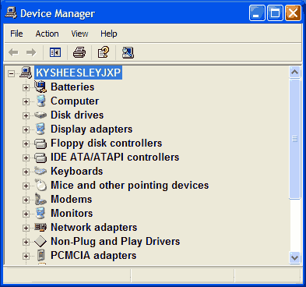
Device Manager displays hardware on your machine.
By default, Device Manager shows you the installed Plug And Play devices. It doesn't show you everything though. You can't see some non-Plug And Play devices and many system level devices. To view them, select View Hidden Devices from the View menu. You'll then see new devices appear, but these still aren't the missing devices.
To view missing devices, close Device Manager. On the Systems Properties page, click the Advanced Tab. Next, click Environment Variables. When the Environment Variables screen appears, click New in the System Variables box.
You'll then see the New System Variable screen. Enter devmgr_show_nonpresent_devices in the Variable Name field and 1 in the Variable Value field as shown in Figure B. Click OK to save the new variable and OK again to close the Environment Variables screen.

Figure B
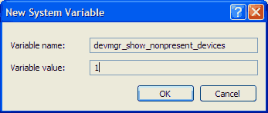
Set the environment variable to show missing devices.
Click the Hardware tab again and click Device Manager. Select View Hidden Devices from the View menu. You'll now see the Device Manager screen shown in Figure C. This time, you may see new branches as well as devices with icons that are grayed out. Gray icons represent those devices that are missing from your system.

Figure C
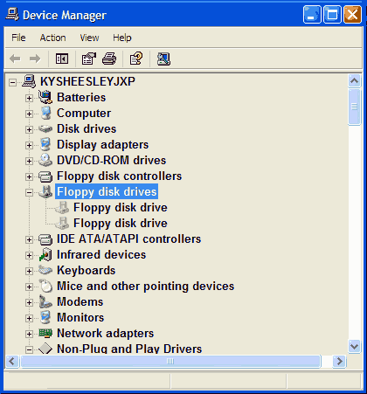
Device Manager displays missing devices with gray icons.
To remove a device, right-click a grayed-out device and select Uninstall. Be careful when you do however. Make sure you don't need the device or plan to reinstall it later. If you do need it later, XP will reinstall it at that time.
More Device Manager tricks
There's a lot more you can do with Windows XP's Device Manager. For some additional tricks, you can read Greg Shultz's article "Get the most from Windows XP's Device Manager".

